SERVICENOW PROJECT

Automated Network Request Management
  - Final Project Report

Document type | Final project report
Platform | ServiceNow Personal Developer Instance (PDI)
Instance reference | dev446474 (Australia release shown in instance)
Document date | 20 October 2026
Source templates | Final Report Template; FSD Documentation Format; UAT template
Project owner / identifiers | SkillWallet ID: SWUID2026232277. Project tester/demonstrator: PILLEM RAHUL. No additional team members were supplied.
Document status | Template-aligned report. SkillWallet ID and GitHub repository are included. The narrated demo is recorded and included at Project Demonstration/Automated_Network_Request_Management_Demo_With_User_Voice.mp4; public GitHub video URL awaits upload. Open QA and data-integrity follow-ups are disclosed.
GitHub repository | https://github.com/rahulp06/Automated_Network_Request_Management_in_ServiceNow

Prepared from observed instance screens and tester-confirmed outcomes. Credentials and full test-mail address are intentionally omitted.

Report contents
- 1. Introduction
- 2. Ideation Phase
- 3. Requirement Analysis
- 4. Project Design
- 5. Project Planning & Scheduling
- 6. Functional and Performance Testing
- 7. Results
- 8. Advantages & Disadvantages
- 9. Conclusion
- 10. Future Scope
- 11. Appendix
Template alignment: section order follows the supplied Project Report Format. Where original discovery artifacts, planning dates, source code, or team details were not supplied, the report states the limitation rather than inventing evidence.

1. INTRODUCTION

1.1 Project Overview
Automated Network Request Management is implemented as a ServiceNow Service Catalog experience for collecting network-service request details, creating standard Request (REQ) and Requested Item (RITM) records, routing decisions through the existing approval process, and generating lifecycle notifications. This report summarizes the behavior verified during the current Personal Developer Instance (PDI) QA and handover session.

1.2 Purpose
The project aims to standardize network-request intake, validate important information at submission time, make approval decisions traceable through ServiceNow records, and notify stakeholders when requests are created or acted on. The document gives a reproducible view of the current configuration and its verified state.

2. IDEATION PHASE

2.1 Problem Statement
Network service requests can be delayed or difficult to track when request details arrive through inconsistent channels, required information is missing, approval status is communicated manually, or the relationship between a request and its fulfillment item is unclear. The solution uses a defined catalog form and an approval-and-notification lifecycle to improve consistency and traceability.

2.2 Empathy Map Canvas
The following is a synthesized design assumption for the project (not a record of formal interviews).
Persona | Needs / thinks | Pain points | Desired outcome
Requester | Wants a simple form and status visibility. | Repeating information; uncertainty about approval. | Submit complete details and receive clear updates.
Approver | Needs enough context to decide. | Incomplete request details; missed notifications. | Review request details and approve or reject consistently.
Network / service team | Needs structured, traceable requests. | Requests spread across channels; unclear ownership or state. | Consistent request records linked to fulfillment and decision history.
ServiceNow administrator | Needs stable configuration and diagnosable notifications. | Email-provider restrictions and queued messages. | Reliable configuration with test routing and audit evidence.

2.3 Brainstorming
- Use a Service Catalog item as the single entry point for network requests.
- Make requester, contact, and connection-type details mandatory where required by the current catalog form.
- Create linked REQ/RITM records and route requests through the existing approval workflow.
- Generate submission and decision notifications, then retain request state and fulfillment stage in ServiceNow.
- Use a disposable test mailbox during email troubleshooting so unrelated queued notifications are not released to their original recipients.

3. REQUIREMENT ANALYSIS

3.1 Customer Journey Map
Journey step | User / system action | Expected outcome
Discover | Requester opens Service Catalog > Top Requests > Network Request. | Correct catalog item is available.
Enter details | Requester fills the starred variables and any relevant optional details. | Required values can be validated before order submission.
Submit | ServiceNow processes the catalog order. | A REQ and linked RITM are created.
Review | Existing approval workflow routes the request for a decision. | Approval or rejection is recorded through the configured path.
Notify | Notification record is generated and SMTP processes outbound mail. | Stakeholders receive lifecycle messages; test routing is used during QA.
Track | Requester / service team checks request and item state. | State and fulfillment stage can be reviewed on records.

3.2 Solution Requirements
ID | Requirement | Evidence / status
FR-01 | Provide a Network Request catalog form. | Verified; catalog item opened.
FR-02 | Validate required catalog variables before ordering. | PASS; Order Now was blocked with required values missing.
FR-03 | Create a parent Request and a related Requested Item. | PASS; REQ0010004 links to RITM0010005.
FR-04 | Support approval and rejection using the existing workflow. | PASS; both outcomes tester-confirmed.
FR-05 | Generate submission / created / approval notifications. | PASS; message records and test inbox messages observed.
FR-06 | Track approval and fulfillment states. | Verified for parent and item sample; item remains State=Open after approval.
NFR-01 | Protect credentials and avoid accidental real-recipient delivery during QA. | Test routing enabled; password not included in artifacts.
NFR-02 | Provide performance/load capacity. | Not tested; no formal load benchmark available.

3.3 Data Flow Diagram
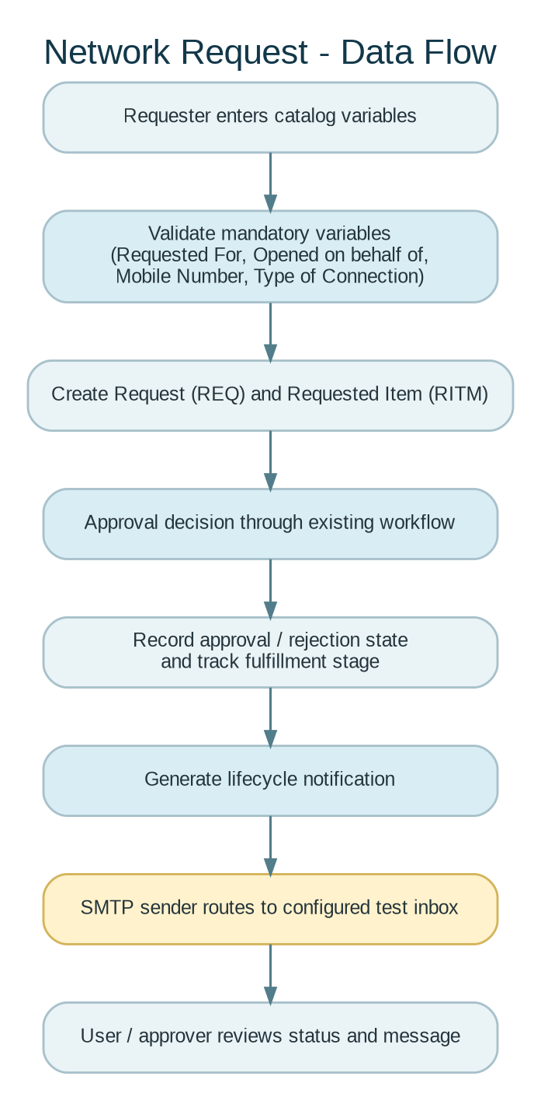
Figure 1. Logical data flow based on the observed catalog, REQ/RITM records, approval test, and outbound notifications.

3.4 Technology Stack
Component | Observed / documented use
Platform | ServiceNow Personal Developer Instance; Australia release shown in the portal.
Intake UI | Service Catalog item titled Network Request / Network Request Management.
Data records | Request (REQ) and Requested Item (RITM) records; linked item visible in the parent request related list.
Workflow | Existing configured approval path; approval and rejection tests reported successful.
Notification | ServiceNow outbound email notification records.
SMTP for QA | Custom SMTP account using smtp.gmail.com, port 587, STARTTLS; Google App Password entered in ServiceNow and not stored here.
Safe-routing control | glide.email.test.user configured to redirect outbound messages to the disposable QA inbox; full address omitted.
Source repository / external APIs | None supplied or independently verified for this configuration-based project.

4. PROJECT DESIGN

4.1 Problem-Solution Fit
A Service Catalog item is a practical fit for a structured request because it presents a consistent form, uses mandatory-variable validation, and lets the platform create linked request records. Existing approval configuration and email notifications extend the lifecycle without needing a separate custom web application.

4.2 Proposed Solution
The current solution uses a catalog item to collect requester and connection data; ServiceNow creates standard request records; the existing approval workflow handles approve/reject decisions; and notifications report submission and decision events. Email troubleshooting introduced a custom SMTP account and test-recipient routing for verification. This documents the observed setup, not an independent audit of every Flow Designer action, script, ACL, or property.

4.3 Solution Architecture
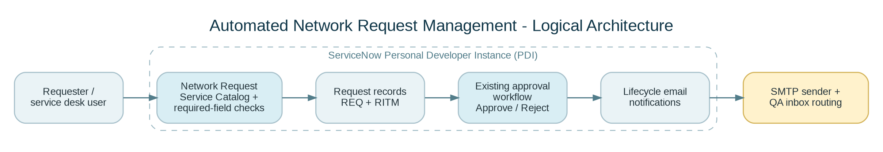
Figure 2. Logical architecture. The test inbox is a QA destination, not a production email-routing recommendation.

5. PROJECT PLANNING & SCHEDULING

5.1 Project Planning
Phase | Scope | Current status
Ideation / requirements | Define network-request problem, actors, and required form behavior. | Retrospective summary; original ideation artifacts not supplied.
Design | Catalog item, request lifecycle, approval route, notifications. | Existing configured solution observed.
Development / configuration | ServiceNow catalog and approval/notification configuration. | Core tested paths operational.
Phase 4 - QA | Required-variable validation, approval/rejection, email, linkage checks. | Core functional QA passed; follow-ups listed.
Phase 5 - documentation | Final report, FSD, UAT record, evidence, limitations. | Prepared in this template-aligned pack.

A dated sprint plan, milestone schedule, team assignment list, and effort estimates were not present in the supplied evidence. This report therefore avoids inventing planned or actual durations.

6. FUNCTIONAL AND PERFORMANCE TESTING

6.1 Functional Testing
Test ID | Scenario | Observed outcome | Status
FT-01 | Open Network Request catalog item. | Catalog form opened. | PASS
FT-02 | Submit with required variables missing. | Order Now was blocked; required markers were visible. | PASS
FT-03 | Create request and linked item. | REQ0010004 linked to RITM0010005. | PASS
FT-04 | Approval path. | Approval test confirmed successful; REQ sample showed Approved. | PASS
FT-05 | Rejection path. | Tester confirmed rejection test succeeded; test record ID not captured. | PASS - tester confirmed
FT-06 | Notification generation. | Send-ready notification had subject and populated body. | PASS
FT-07 | SMTP authentication. | Test Connection succeeded after removing spaces from App Password. | PASS
FT-08 | Outbound email delivery. | SMTP Sender Running; notification messages visible in test inbox. | PASS
FT-09 | Queue fully drains. | Queue fell from 20 to 5; remaining five not inspected. | FOLLOW-UP
FT-10 | Inbound email. | Diagnostics showed receiving non-operational / no received email. | OUT OF SCOPE / REVIEW
FT-11 | Request/item direct approval audit link. | Parent Approvers and Group approvals tabs appeared empty on one sample. | FOLLOW-UP
FT-12 | Performance / load benchmark. | No formal concurrent-user/load test conducted. | NOT TESTED

6.2 Performance Testing
Formal throughput, concurrency, response-time, endurance, and capacity tests were not performed. Diagnostics showed an SMTP sender processing time of 18 ms in one observed refresh, but this single operational value is not a representative application performance benchmark.

7. RESULTS

7.1 Output Screenshots
The following selected evidence images are adapted from user-provided instance screenshots. Email-address banners or sender columns have been excluded from the reproduced images where practicable; full SMTP credentials are not included anywhere in this pack.
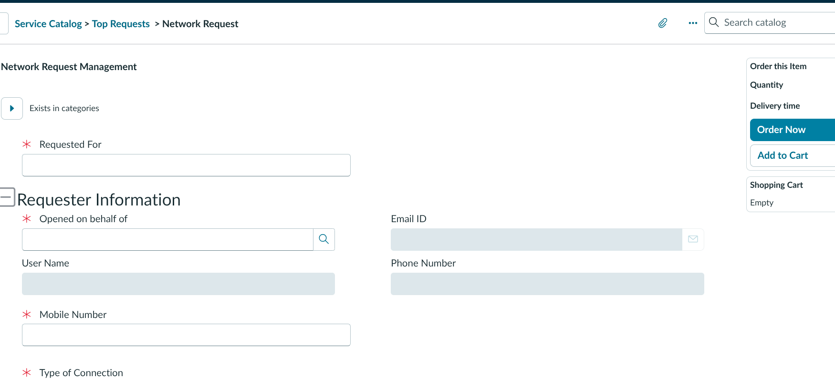
Figure 3. Network Request catalog form; mandatory variables are marked with red asterisks.

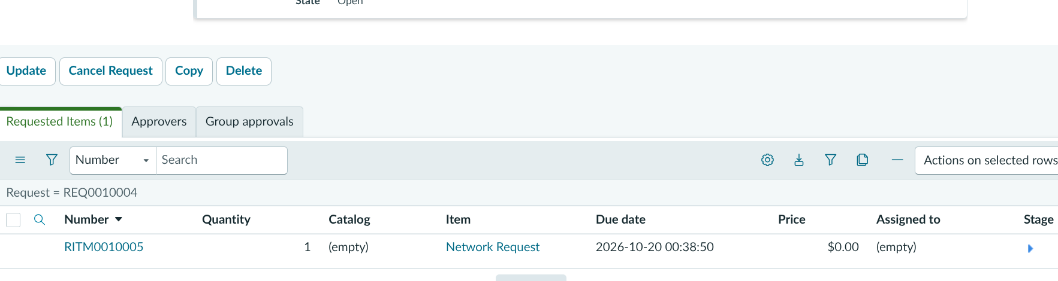
Figure 4. Parent Request related list showing RITM0010005 for REQ0010004.
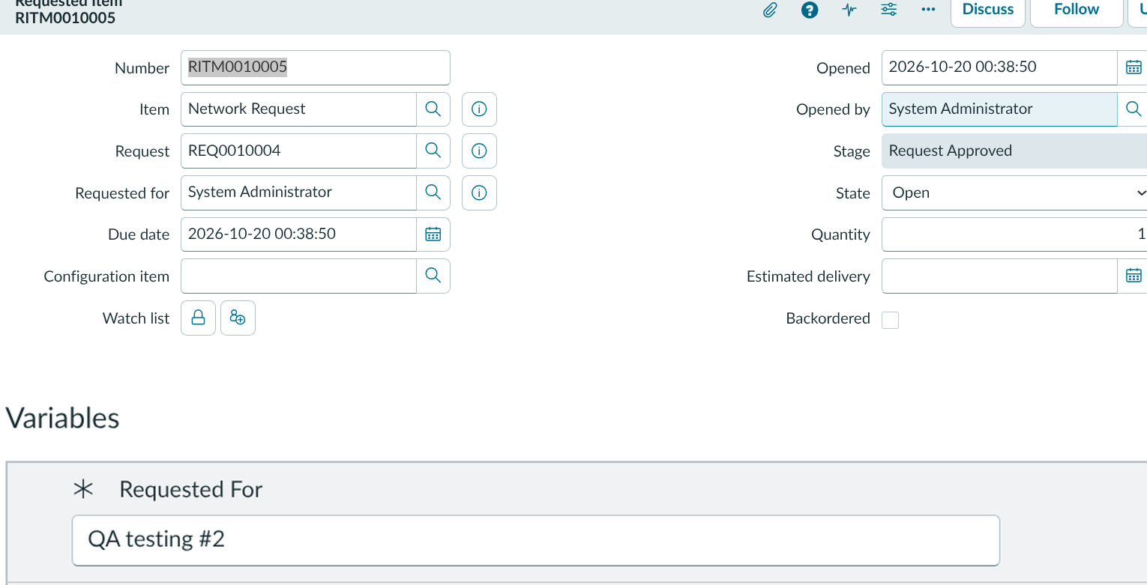
Figure 5. Requested Item detail: item, parent request, stage, state, quantity, and intentionally entered test variable.

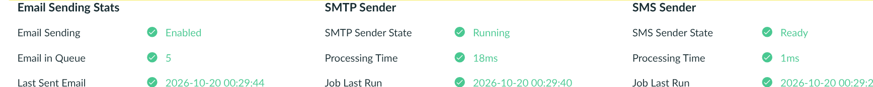
Figure 6. Email Diagnostics after SMTP sender activation: sending enabled, sender running, queue at five, and a last-sent timestamp.

Figure 7. Cropped test-inbox view showing Network Request notification subjects; sender and inbox address columns omitted.

8. ADVANTAGES & DISADVANTAGES
Advantages observed / intended | Limitations / risks remaining
Consistent catalog intake and required-variable validation. | Parent Request Approvers/Group approvals lists were empty for one inspected record; direct approval-record trace may be needed for audit.
Standard REQ/RITM linkage supports tracking. | RITM may remain Open after approval while fulfillment is pending; completion was not demonstrated.
Existing approval/rejection paths reduce manual decision handling. | Exact rejection test record ID was not captured in the evidence screenshots.
Outbound notifications delivered after SMTP setup. | Five queued emails remain as of last check; their content/state has not been inspected.
Test-recipient routing supports safer QA. | Routing is global and redirects unrelated platform notifications while enabled.
ServiceNow platform removes need for a separate UI/backend deployment. | No formal performance/load test or production mail/security review was provided.

9. CONCLUSION
The core Network Request workflow has evidence of successful catalog validation, REQ/RITM creation and linkage, approval and rejection testing, notification generation, SMTP authentication, sender processing, and outbound delivery to a test inbox. The project is ready for demonstration and handover as a PDI-based project draft, subject to the listed queue, audit-trace, cleanup, and sign-off follow-ups. It is not represented as a production deployment certification.

10. FUTURE SCOPE
- Trace the approval record to the exact approval table/record and preserve approval IDs in the QA evidence index.
- Inspect the remaining five queued messages and document their state and intended disposition before changing test routing.
- Confirm whether inbound email is needed; if it is not in scope, disable receiving using the approved instance settings and recheck diagnostics.
- Add automated regression tests for required variables, approve/reject branches, and notification recipient/content rules.
- Run documented load, concurrency, and response-time tests before any production-style readiness claim.
- Move SMTP to an approved organizational mail service for production and apply the organization’s secret rotation policy.

11. APPENDIX

11.1 Source Code
No repository or custom source-code bundle was supplied for this configuration-based ServiceNow project. The report describes the UI-observed platform configuration and tested behavior only.

11.2 Dataset
No external dataset is applicable to the observed catalog/approval workflow. Test data consisted of ServiceNow request records and intentionally entered catalog variables.

11.3 Instance and Demo
GitHub repository URL: https://github.com/rahulp06/Automated_Network_Request_Management_in_ServiceNow. Demo video included in package: Project Demonstration/Automated_Network_Request_Management_Demo_With_User_Voice.mp4 (~98 seconds). Public GitHub video URL: pending repository upload.

11.4 Evidence Record IDs
Record / item | Use in report
REQ0010004 | Parent request observed Approved; parent has related Requested Items (1).
RITM0010005 | Linked Network Request item; Request reference is REQ0010004; Stage=Request Approved; State=Open; Quantity=1.
TASK0020173 | Generic task record created during navigation/testing; blank Short description; left unchanged and pending review.

11.5 Demo Recording Checklist
The supplied demonstration is a narrated screen recording of approximately 1 minute 38 seconds. It introduces the objective, shows catalog mandatory-field validation, opens the approved REQ0010004 and linked RITM0010005, describes the tested approval/rejection paths, and shows outbound notification evidence. If the coordinator requires a minimum duration longer than the supplied clip, extend the walkthrough before submission. Do not show passwords, App Passwords, the full test-mail address, browser-saved secrets, or real personal data.
For the approval/rejection portion, use real existing evidence only. The exact rejection-test record ID was not captured in the current evidence, so locate it before claiming that it is shown on screen; otherwise state that rejection was tested separately and is documented as tester-confirmed.

